Lab – Blinking an LED Using Blockly

Objectives

Part 1: Open Packet Tracer and Examine Blockly Program for LED Blinking

Part 2: Control a RGB LED using Blockly

Background

Blockly is a visual programming language that lets users create programs by connecting blocks, that represent different logic language structures, rather than by writing the actual code. Blockly runs within a web browser and can translate the visually created program as JavaScript, PHP, or Python. In this lab, you will use Blockly to examine Blockly programming and to control an LED.

Scenario

Using Blockly programming to control an IoT object LED. In this lab, Cisco Packet Tracer is used as it provides Blockly support with IoT objects.

Required Resources

* Cisco Packet Tracer 7.1.1 and above is installed and available.

1. Launch Cisco Packet Tracer (PT) and Use Blockly

In Part 1, you will access the Cisco Packet Tracer program and examine LED control using Blockly programming.

* 1. Launch Packet Tracer.
     1. Double click the Cisco Packet Tracer icon to open the PT program.



* + 1. The user interface is shown.

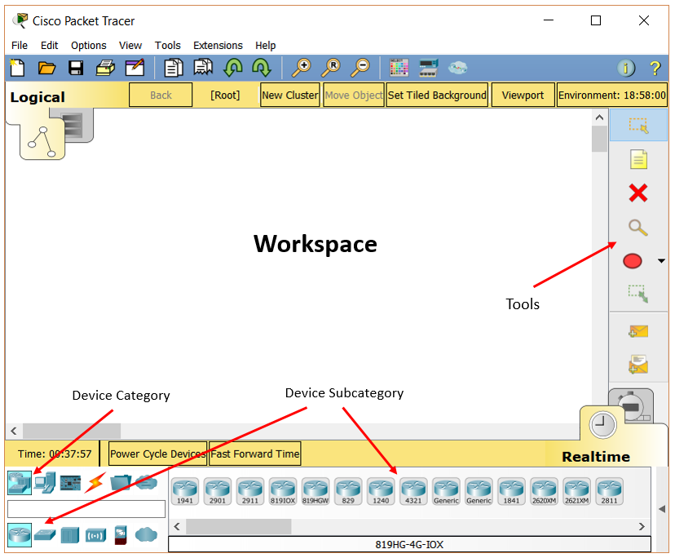

* + 1. Click on the **Components** category, then click **MCU Board** and drag it to the workspace.

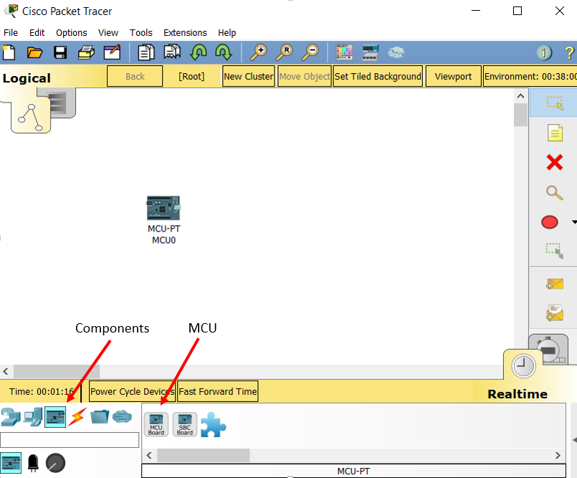

* + 1. Click the subcategory **Actuators**, select **LED** and drag it to the workspace.

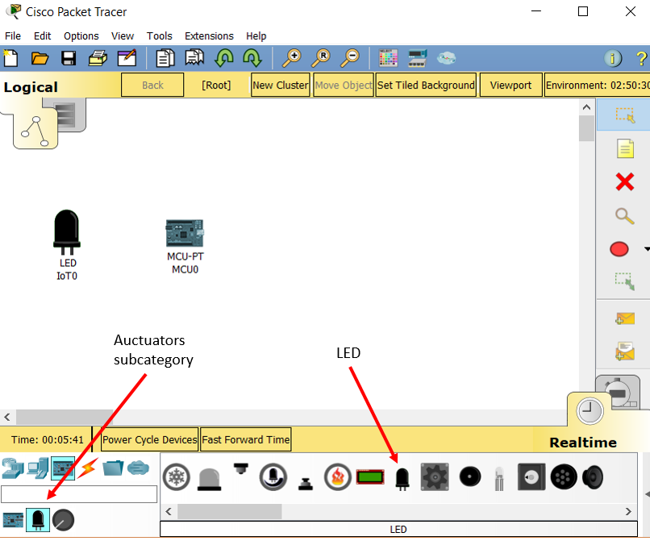

* + 1. Click the **Connections** category, select **IoT Custom Cable** to link MCU at port **D1** and LED at port **D0**.

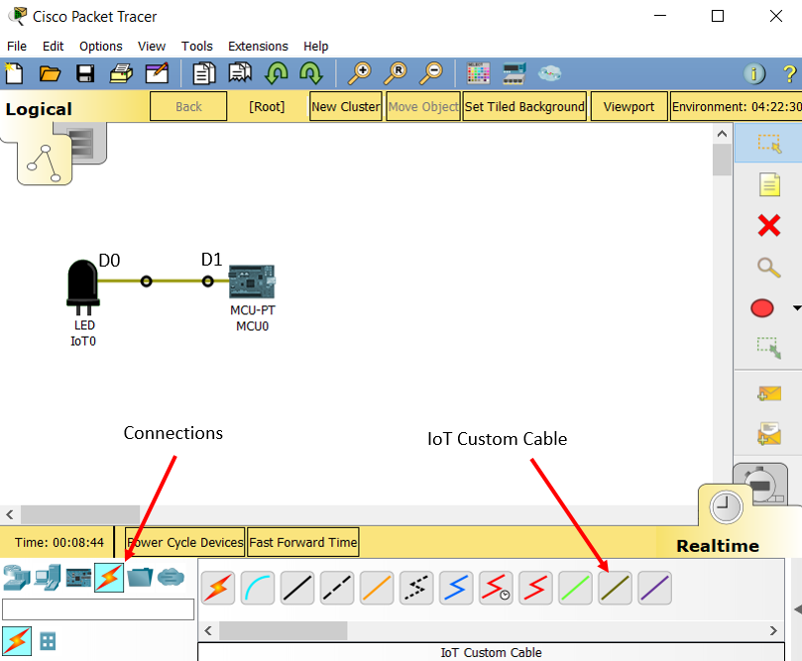

* + 1. Double click the **MCU**. Its configuration window displays.

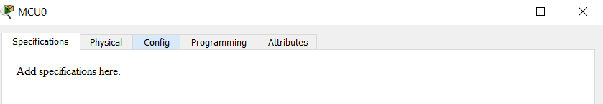

* + 1. Click the **Programming** tab. (If you do not see the Programming tab, click the **Advanced** button at the lower right corner.)

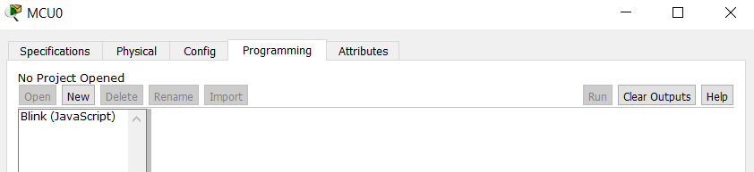

* 1. Examine a prebuilt Blockly program
     1. Under the note **No Project Opened**, click **New**. In the **Create Project** window, enter **Blinking LED** as the project name. In the **Template** dropdown menu, select **Blink – Visual**.

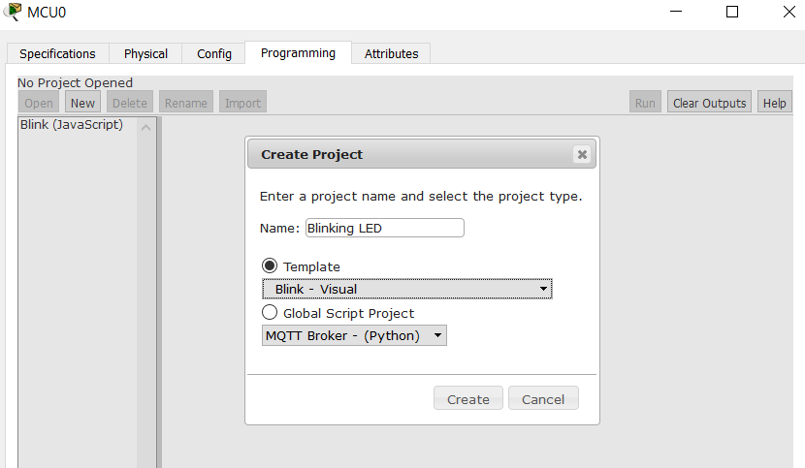

* + 1. Click **Create**.

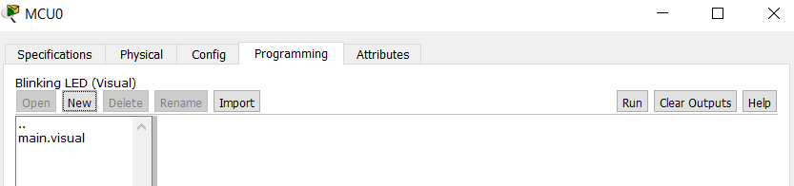

* + 1. Double-click **main.visual**. The prebuilt Blockly program displays.

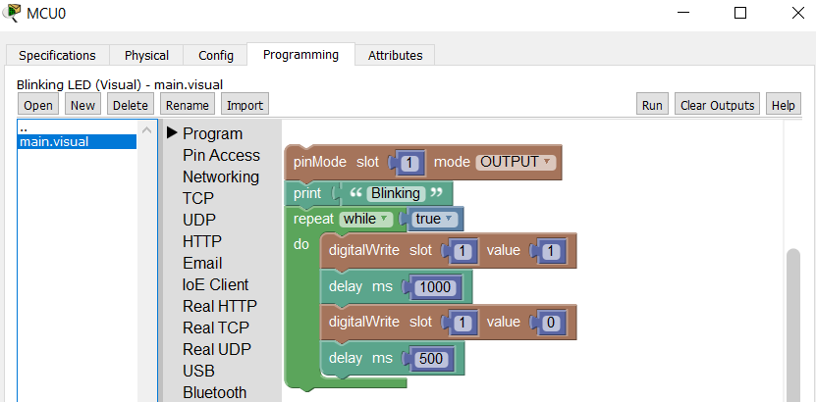

* + 1. Click **Run**. Does the LED blink?

No

* + 1. Click **Stop**, and change the **Value** field of the first **digitalWrite** block to 1023.

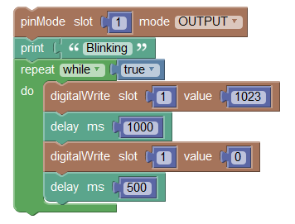

* + 1. Click **Run**, does the LED blink?

**Yes**

Why was it not blinking when the value was not set to 1023?

_________________________________________________________________________________

_________________________________________________________________________________

**The digital out takes the value 1023 as “HIGH”, and turns on the output current**.

* + 1. Click on the LED and study its specification.

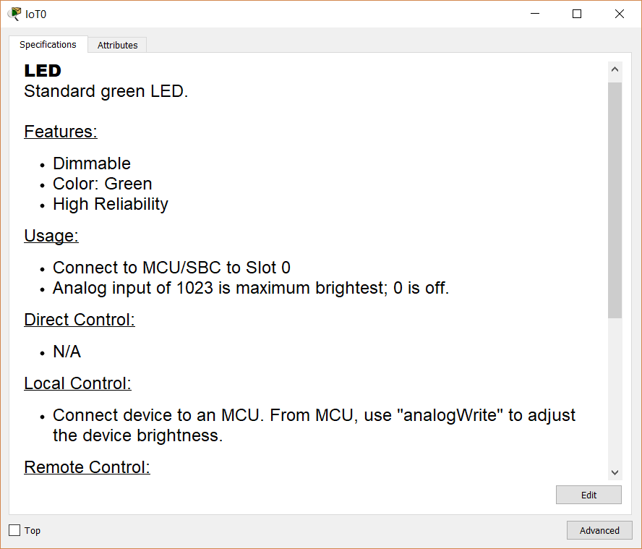

* + 1. It indicates that we can use “analogWrite” to adjust the device brightness. Expand **Pin Access** group and use the **analogWrite** block to replace **digitalWrite** block.

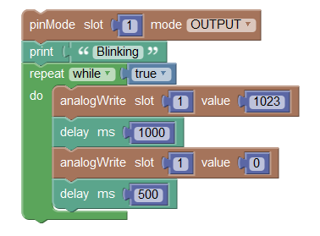

* + 1. Now change the values of the first and second **analogWrite** blocks and observe the different LED brightness levels.

1. Control a RGB LED using Blockly

In Part 2, you used Blockly to control an RGB LED. An RGB can display different colors with the combination of red, green, and blue.

* 1. Add an MCU and an RGB LED.

In Step 1, you add another MCU board and a RGB LED into the workspace.

* + 1. Click the subcategory **Actuators,** select **RGB LED** and drag it to the workspace. Add another MCU board.

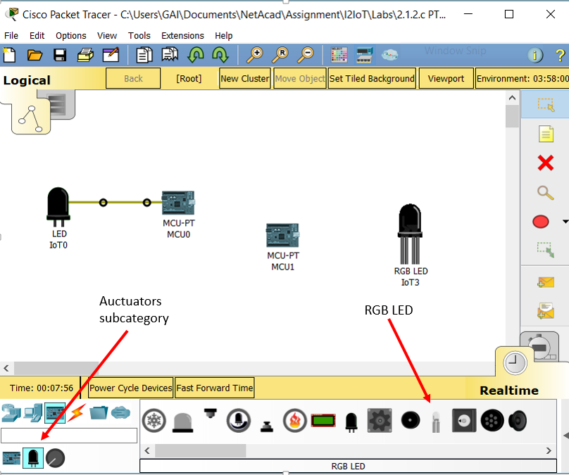

* + 1. Click the **Connections** category, select three **IoT Custom Cable**s to link MCU and RGB LED.

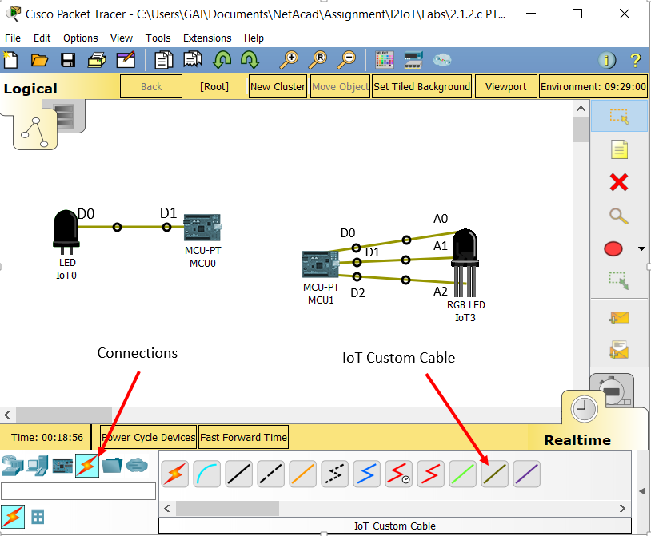

* + 1. Click **RGB LED** and review its specification. Note different pin inputs represent different colors.

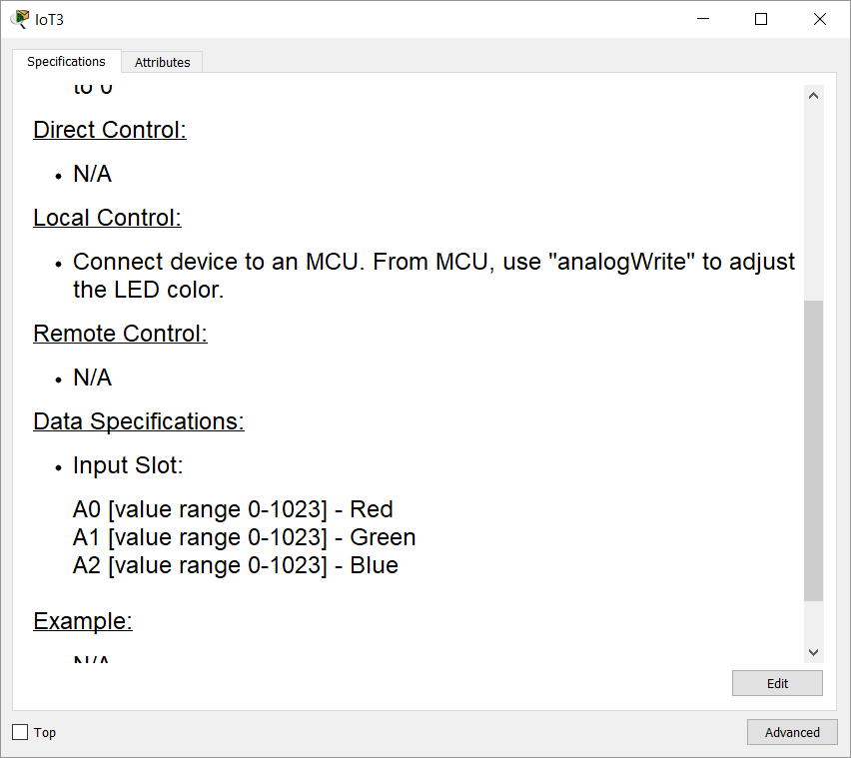

* + 1. Open the prebuilt Blockly program. Click MCU -> Programming. Under the note **No Project Opened**, click **New**. In the **Create Project** window, enter **Blinking RGB LED** as the project name. In the Template dropdown menu, select **Blink – Visual**.

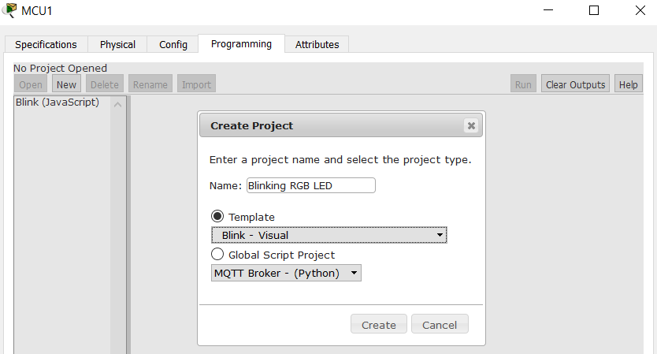

* + 1. Click **Create**. Double-click main.visual. The prebuilt Blockly program displays.

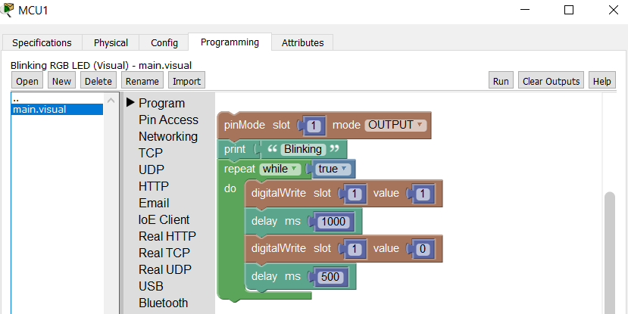

* 1. Modify the Blockly program
     1. Expand **Pin Access** group, and add two more **pinMode** blocks to set three slots as **OUTPUT** (from MCB to send a signal to RGB LED).

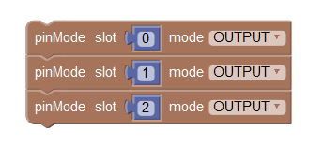

* + 1. From the **Pin Access group**, select **analogWrite** blocks to replace **digitalWrite** blocks. Also, add a few **print** blocks.

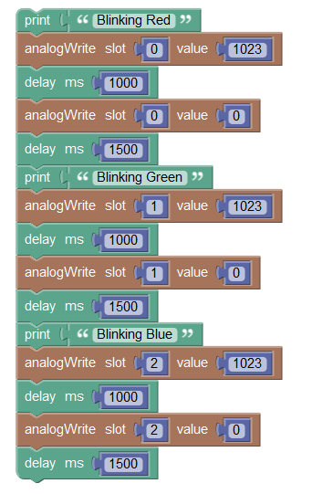

* + 1. The final program is as follows:

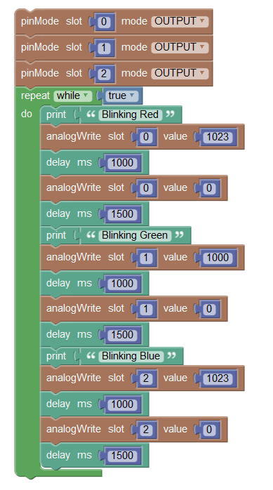

* + 1. Run the program. The LED should display RED, GREEN, and BLUE in sequence.

**Challenge**

Modify the program to show a combined color from all three inputs with different, randomly generated values for each slot.

**An example is as follows:**

